1 a) **Inferior good** is a good whose demand increases when the consumer's income decreases and whose demand decreases as the consumer's income increases. For example, secondhand cars are cheaper. **Giffen good** is a special type of inferior good whose demand increases as the price of the good increases. An **example could be rice** which is a staple food of a region and majority of the food consumption is rice that cannot be substituted.

b) P= Rs 5 Q= 40 units

c) F= P(1 + i)n = Rs 8,14,447

d) Goods related to fashion donot follow the Law of Demand and their demand increases even with a rise in their prices. For example, if any particular dress is in fashion then demand for such dress will increase even if its price is rising.

e)

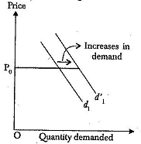 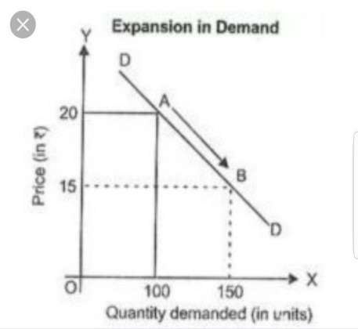

2a) Qx= 12000- 4200 (11) + 12000(7) + 750( 14)

= 60,300

Price elasticity of X = 0.766

Income elasticity of X = 1.39

b) Cross elasticity= 0.17

3 a)

|  |  |  |  |  |
| --- | --- | --- | --- | --- |
| YEARS | X | Y | XY | X2 |
| 2011 | -2.5 | 60 | -150 | 6.25 |
| 2012 | -1.5 | 72 | -108 | 2.25 |
| 2013 | -0.5 | 58 | -29 | 0.25 |
| 2014 | 0.5 | 90 | 45 | 0.25 |
| 2015 | 1.5 | 82 | 123 | 2.25 |
| 2016 | 2.5 | 100 | 250 | 6.25 |
| SUM | 0 | 462 | 131 | 17.5 |

a=77 b= 7.48

a) Y= a + bx

Y= 77 + 7.48X

b) Y= 77 + 7.48 ( 2021- 2013.5)= 133.1 in thousands

4a) By using Gradient formula, A= Rs 23,609.14 (A1= 30,000, G=2000, i= 0.18,n=10 years )

F= A(1+ i)n -1 /n = Rs 555314.57

b) C=4

R= (1 + i/c)c -1 = 16.98%

F= P(1+R)N = Rs 11, 51, 336.691

5a) Students will explain consumer’s equilibrium with help of a graph

b) Students will explain the exceptions to law of demand.